Tracy Michaels

CSC3120

Assignment 2

1)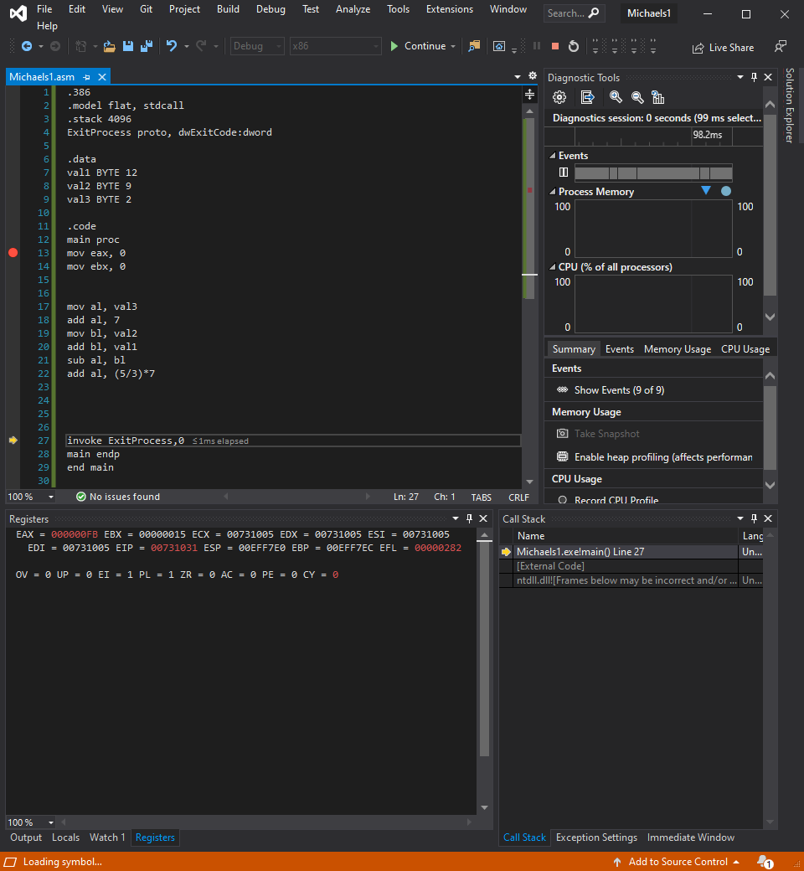

2) 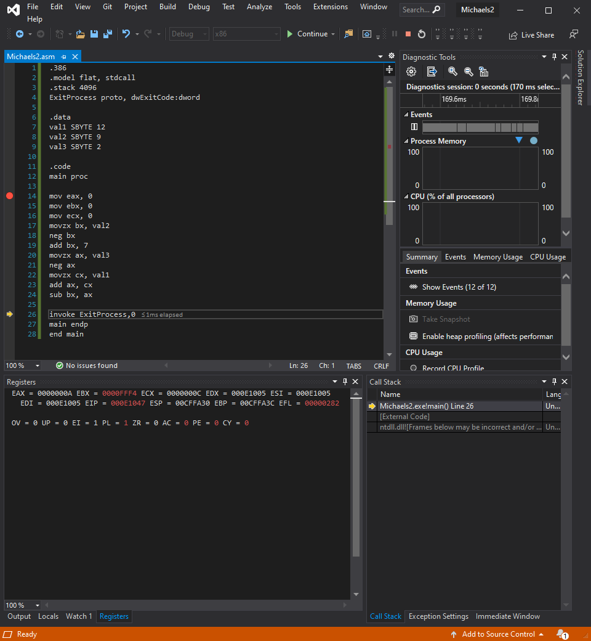

3)

2.1 true

2.2 false

2.3 true

4)

40 bytes

A WORD initializes 2 BYTES of data the inner dup creates 5 2-byte memory allocations that contain the number 7, total 10 Bytes. Outer dup creates 4 of the inner dup for a total of 40 BYTES